Name: AKSHAT KUMAR MISHRA

Class: DevOps, Batch 2021

Sap ID: 500076758

Roll No. R171219004

BRM LAB 1

HOW TO BUILD A MAVEN PROJECT:

Aim: To make a jar file and use it in another program

Step 1: Make a new maven project

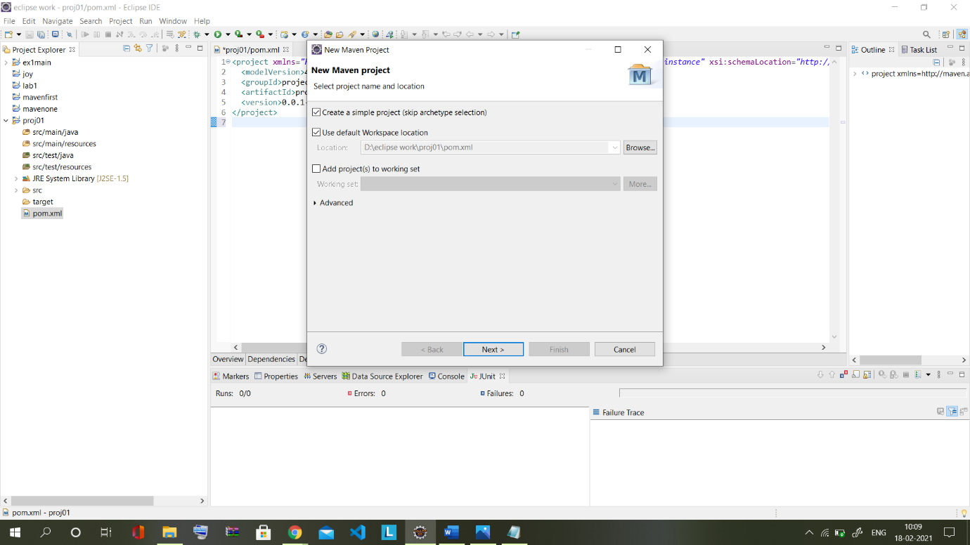

Step 2: Make a new class and write the code: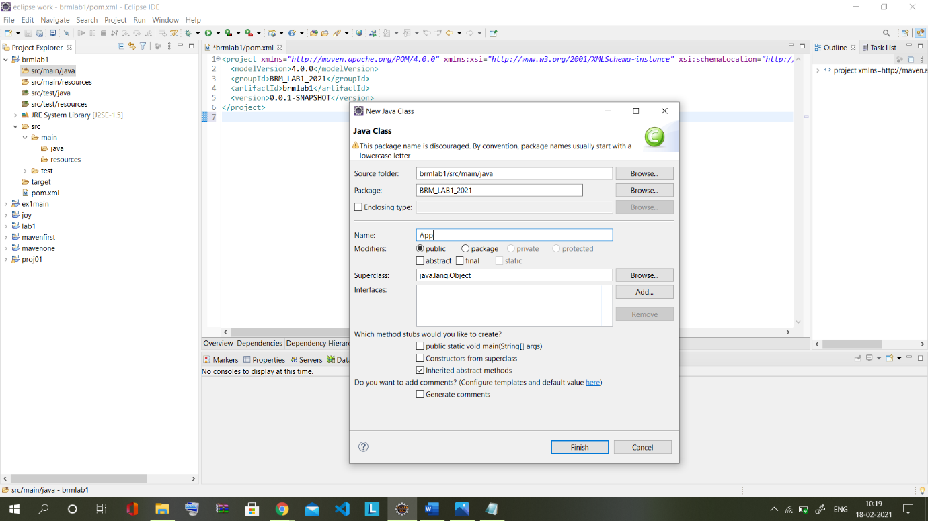

Step 3: Clean, Compile and build:

CLEAN:

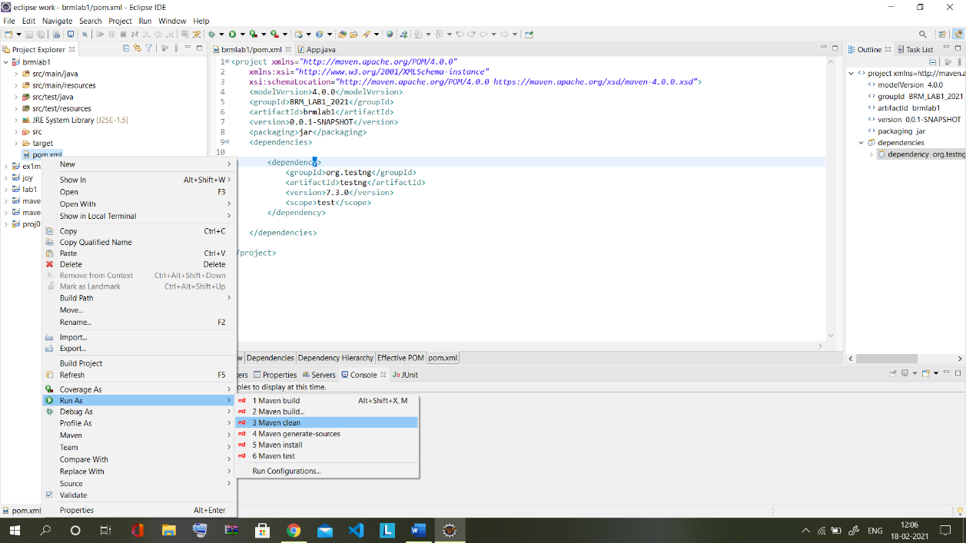

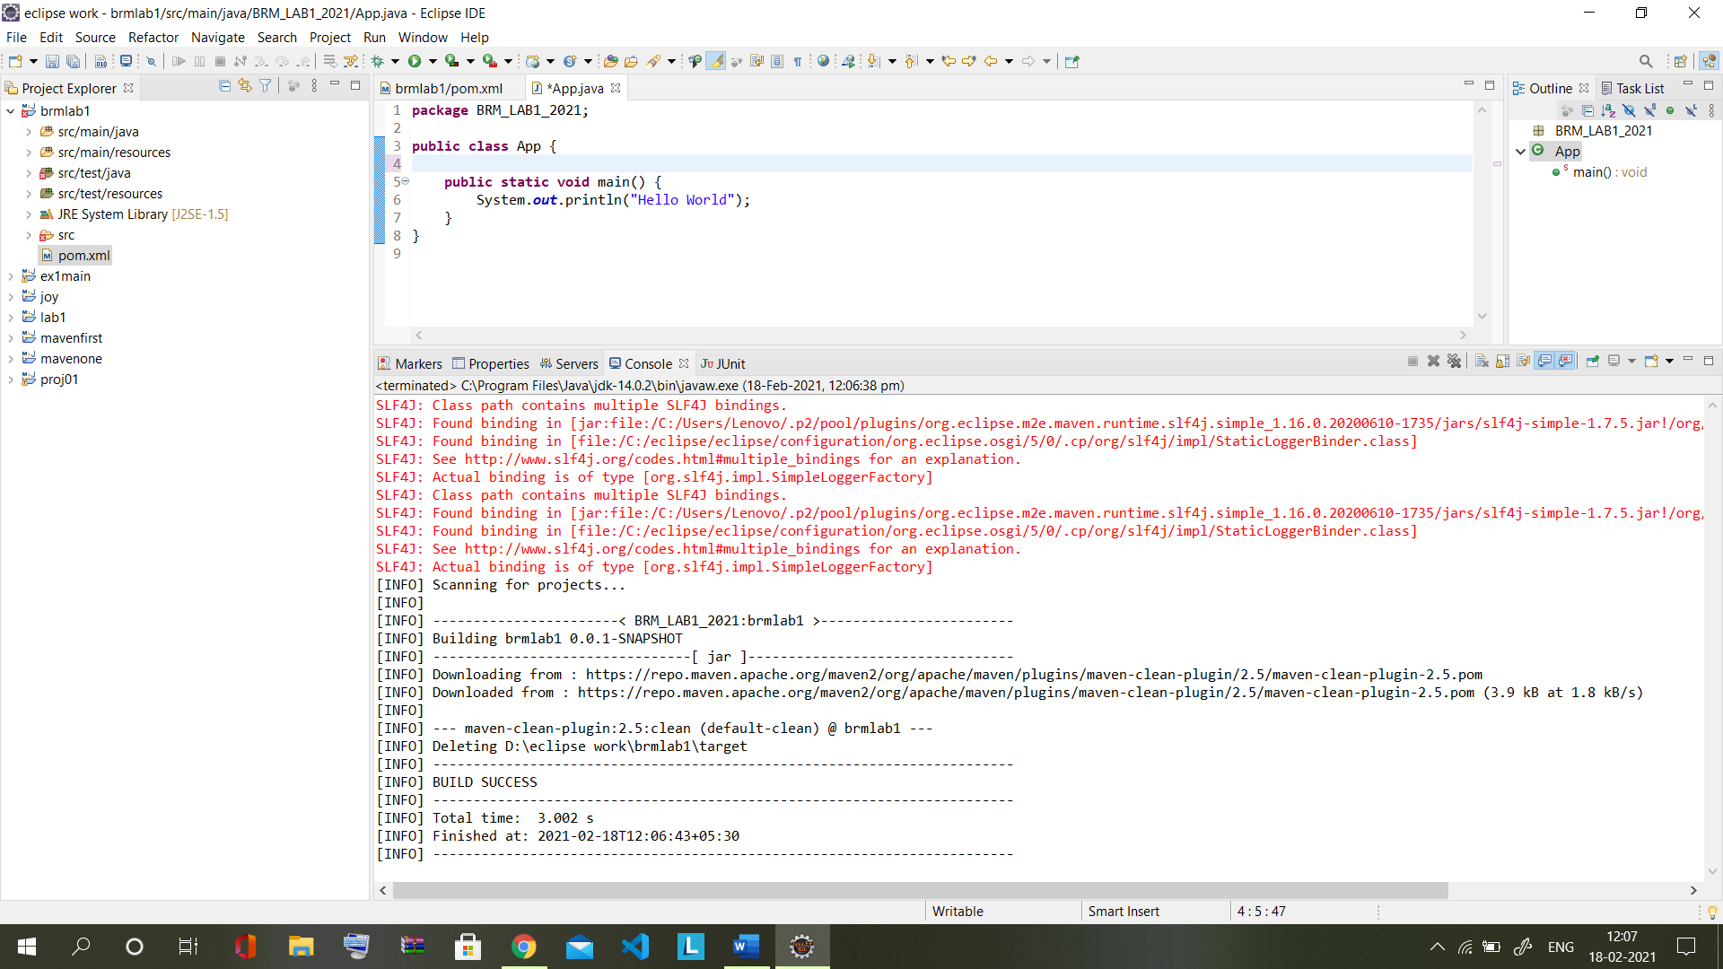

BUILD:

